Student Name : _______________________________________

Part One – Resource Free
Part One contains 6 questions worth 29 marks
Time Allowed : 30 minutes

INSTRUCTIONS TO STUDENTS:
You are required to attempt ALL questions,
Write answers in the spaces provided beneath each question.
Marks are shown with the questions.

Show all working clearly, in sufficient detail to allow your answers to be checked readily and for marks to be answered for reasoning. Incorrect answers given without supporting reasoning cannot be allocated any marks. For any question or part question worth more than two marks, valid working or justification is required to receive full marks.

Question 1 6 marks

Let A, B and C be 2x2 arbitrary matrices, and
Write T (True) and F (FALSE) for each of the following equations:

a) b)
False True

c) d)

False True

e) f)

False True

Question 2 1, 1, 1, 3 – 6 marks

Given find

a) b) |A| c) A⁻¹

d) Matrix C such that A x C = B

Question 3 6 marks

a) Given ,
which two matrices would multiply to give a matrix with order 1 x 2?

b) Given the matrices ,
which of the following products is not valid?
i) ii) iii) iv)

c) The translation is applied to a point followed by .
Find the combined transformation.
d) What transformation is represented by ?
Rotation AC about the origin of 210°

Question 4 1, 1, 2 - 4 marks
Factorise if possible
a) b) c)
Not possible
Question 5 2 marks

Show that matrices of the form when squared are a multiple of the identity matrix.

Question 6 5 marks
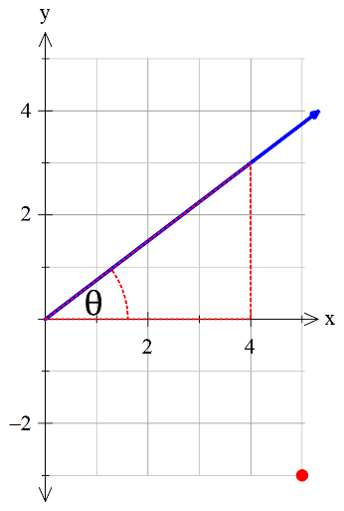
Write the matrix for reflecting the point (5,-3) in the line .
Reflection matrices are of the form

Student Name : _______________________________________

Part Two – Resource Allowed
Part Two contains 4 questions worth 31 marks
Time Allowed : 30 minutes

TO BE PROVIDED BY THE STUDENT
A maximum of one A4 page of notes, one sided.
Standard Items : Pens, pencils, eraser, sharpener, correction tape/fluid, highlighters, ruler.
Special Items: Drawing instruments, templates.
A maximum of three CAS calculators satisfying the conditions set by the SCSA.
INSTRUCTIONS TO STUDENTS:
You are required to attempt ALL questions,
Write answers in the spaces provided beneath each question.
Marks are shown with the questions.
Show all working clearly, in sufficient detail to allow your answers to be checked readily and for marks to be answered for reasoning. Incorrect answers given without supporting reasoning cannot be allocated any marks. For any question or part question worth more than two marks, valid working or justification is required to receive full marks.

Question 1 3, 4 - 7 marks

a) Find the greatest value of λ that makes the matrix singular.

b) Use a matrix method to determine the intersection of the two linear functions

Question 2 4, 3, 2, 2, 2, 1 - 14 marks

a) Determine:
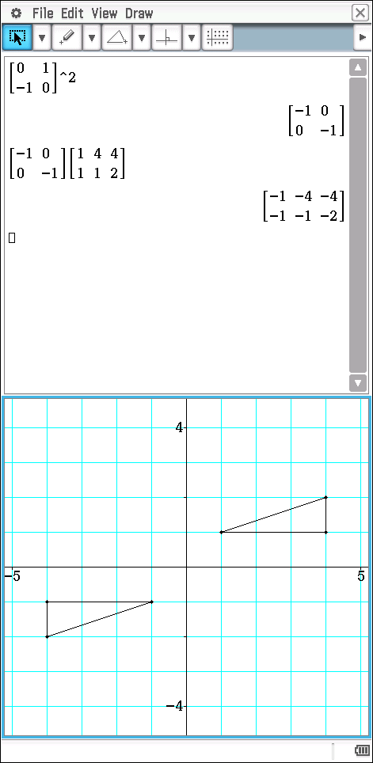

(i) A², and describe it as a transformation.

(ii) A³, and describe it as a transformation.
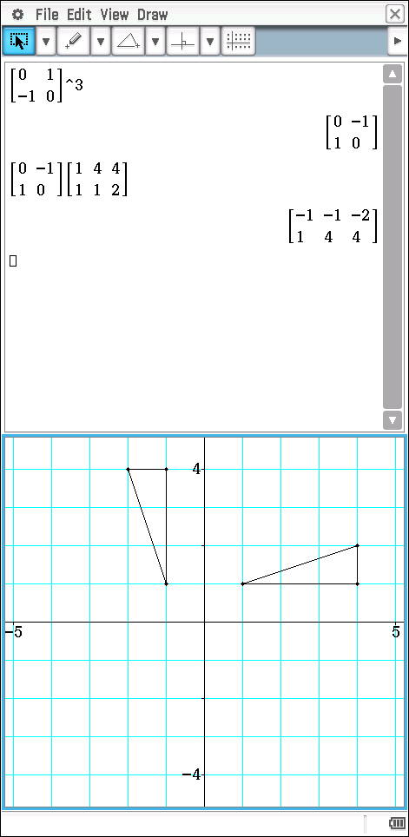


b) If PB = 6[B − 2A], determine P.
c) Find the image of the point P (2, 3) under the transformation that is equivalent to A followed by B.

d) Find the matrix required to transform P’ back to P.

e) If B was applied to a square of side length 5 units, what would be the area of
the resultant figure?

f) If a singular matrix was applied to the square in (d), what would be the shape of
the resultant figure and why?

A singular matrix has a determinant of zero therefore the area of new shape is zero.
Square becomes a line.

Question 3 3, 3, 1 - 7 marks

Top Flight Airlines have three types of aircraft available for lights, each with seating for three classes of passengers. The table below summarises the various seating capacities:

Passenger | Aircraft
 | T1 | T2 | T3
Business Class | 80 | 30 | 60
First class | 40 | 60 | 50
Economy class | 40 | 90 | 40

This may be represented by the matrix

a) On a particular day, there are three fully laden flights of type T1, four of type T2 and two of type T3.
i) Represent this data as matrix B.

ii) Calculate AB and indicate what this represents.

b) Each business class ticket sold gives a profit of $120, each first class ticket sold gives a profit of $100 and each economy class ticket sold gives a profit $80.

i) Represent this data by matrix C.

ii) Calculate the total profit for this day using matrix methods.

c) Without necessarily performing matrix multiplication, state what matrix CA represents.

Profit per plane type

Question 4 3 marks

Determine the equation of the image line formed when all the points on the line are transformed by the matrix

